During the time of studying, we have well provided and imparted for all the necessary and highly valuable of professional knowledge by our teacher in Aptech, we have our faithful, careful style and creative mind in studying in the future.

Project is a good opportunity to apply appropriate for our knowledge and subjects. While performing project, we have actual and valuable experience. After one term, we were getting all one’s thoughts together and labor at a task of project. During executing this project, we have received a lot of helping from our guider, teachers.

Especial, we wish thank to our teacher- Mr: Dao Quang Linh- for his enthusiastic, thoughtful, and careful guidance.

***Definition and Acronyms***

| **Acronym** | **Definition** |
| --- | --- |
|  |  |
|  |  |
|  |  |
|  |  |
|  |  |
|  |  |
|  |  |
|  |  |
|  |  |
|  |  |

1. Project Introduction

1.1. Project Information

* Project Name (English): Car Rental Service Website
* Project Name (Vietnamese): Ứng dụng web dịch vụ cho thuê xe ô tô
* Project Code: CRSW
* Project Type: Web API Project
* Timeline: From 27th September to 8th November

1.2. Project Team

1. **Supervisor**

| **Full Name** | **Phone Number** | **Email** | **Title** |
| --- | --- | --- | --- |
| Dao Quang Linh | 0975 597 339 | hungbkhn@gmail.com | Leader |

1. **Team member**

| **Full name** | **Roll Number** | **Position** | **Phone Number** | **Email** |
| --- | --- | --- | --- | --- |
| Nguyen Dinh Duy | SE03570 | Leader | 0976 678 404 | linhdqse03570@fpt.edu.vn |
| Nguyen Hoang Anh | SE03621 | Member | 01649 02 02 69 | tungntse03621@fpt.edu.vn |
| Vu Duc Anh | SE03628 | Member | 01663 60 56 33 | hungdxse03628@fpt.edu.vn |
| Nguyen Trung Duc | SE03483 | Member | 0989 628 593 | chinhndse03483@fpt.edu.vn |
| Pham Dang Duc | SE03557 | Member | 0989 505 315 | daitqse03557@fpt.edu.vn |

1.3. Product Background

* Today, many households want to build a careful travel spending plan, but want to save costs. Because of the above needs, the car rental service appears as a necessity, satisfying the needs of society.
* Many car owners want to increase their income, and they choose to start their car rental service, according to the needs of society.
* Online car rental activities were born to completely overcome the major limitations of traditional car rental activities.
* In fact, not many user-friendly car rental service websites have been created, so we chose "car rental service" as the topic for the important project. final period.

**1.4. The system existing**

* Here are some overviews of similar existing solutions, overview of existing methods, limitations of some existing applications.

1.4.1. Avis.com

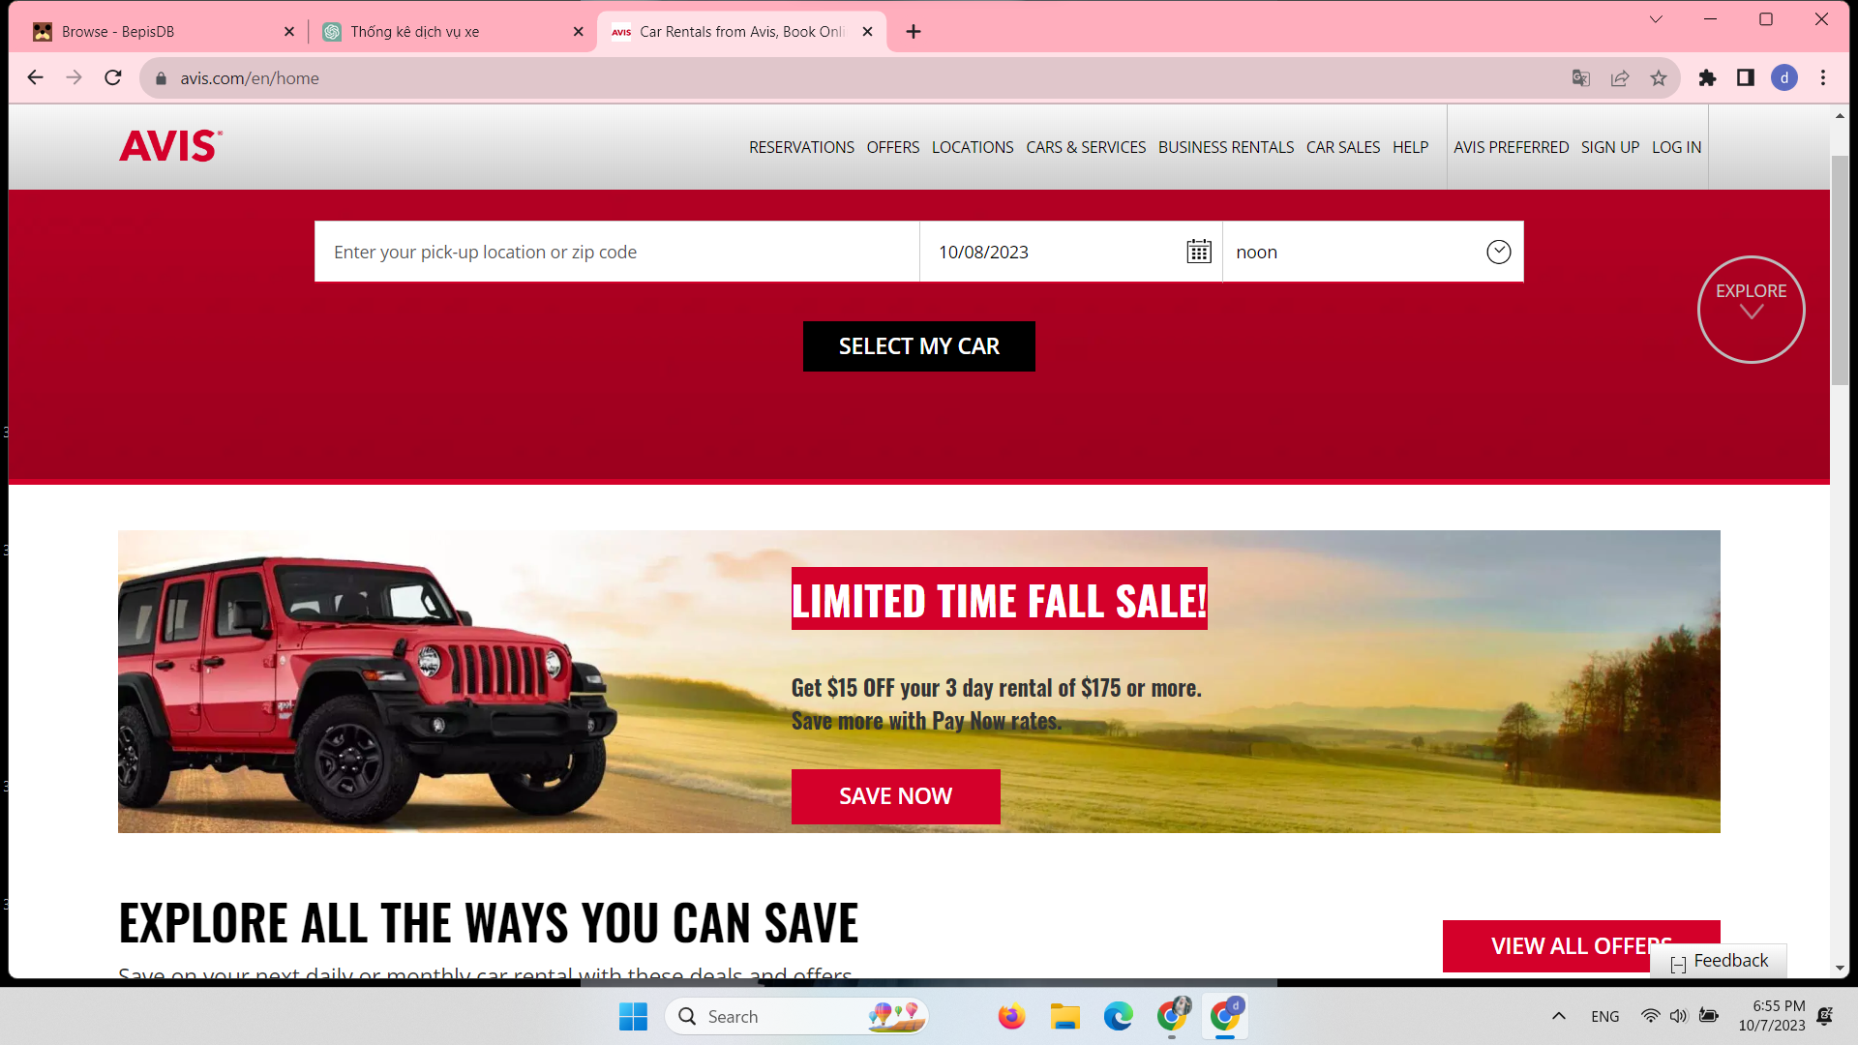

| Pros:   * Easy to use. * Support for search owners’s names; informations of owners, car….; times-setting * Personalized. * Information is accurate and reliable. | Cons:   * Users and car owners must download app of web to fill in their necessary informations. * The interface is rough and looks unfriendly * No support Vietnamese |
| --- | --- |

1.4.2. Xego.vn

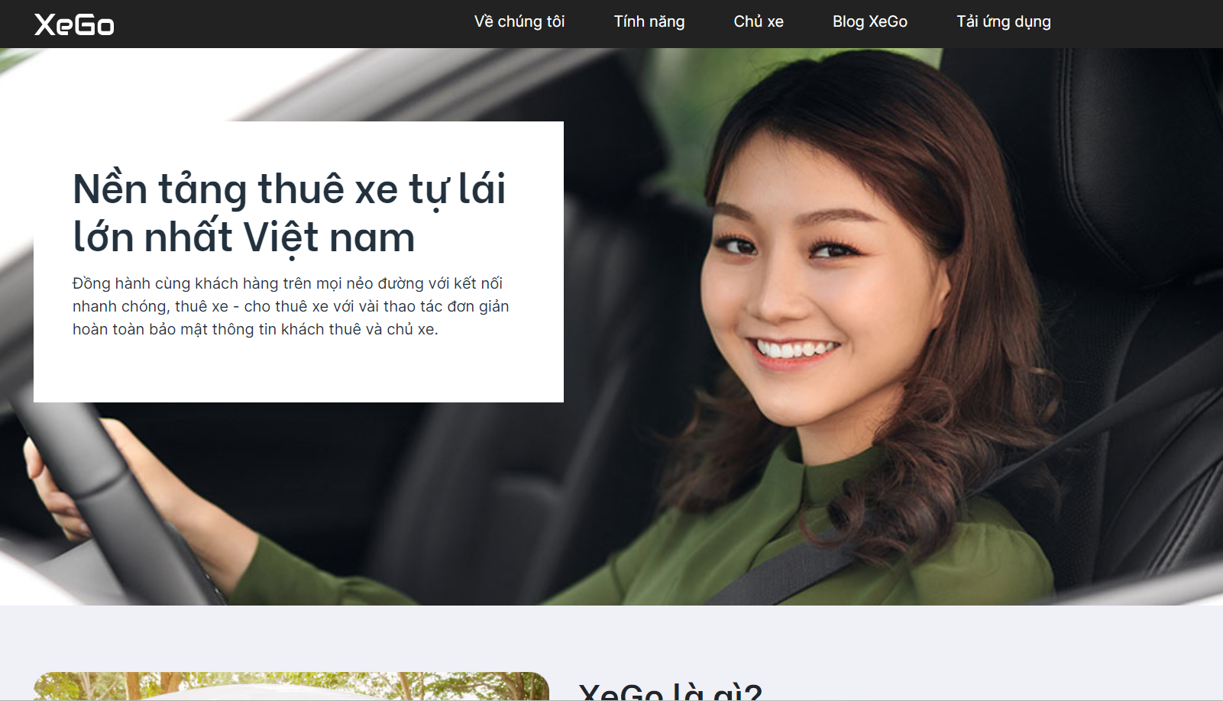

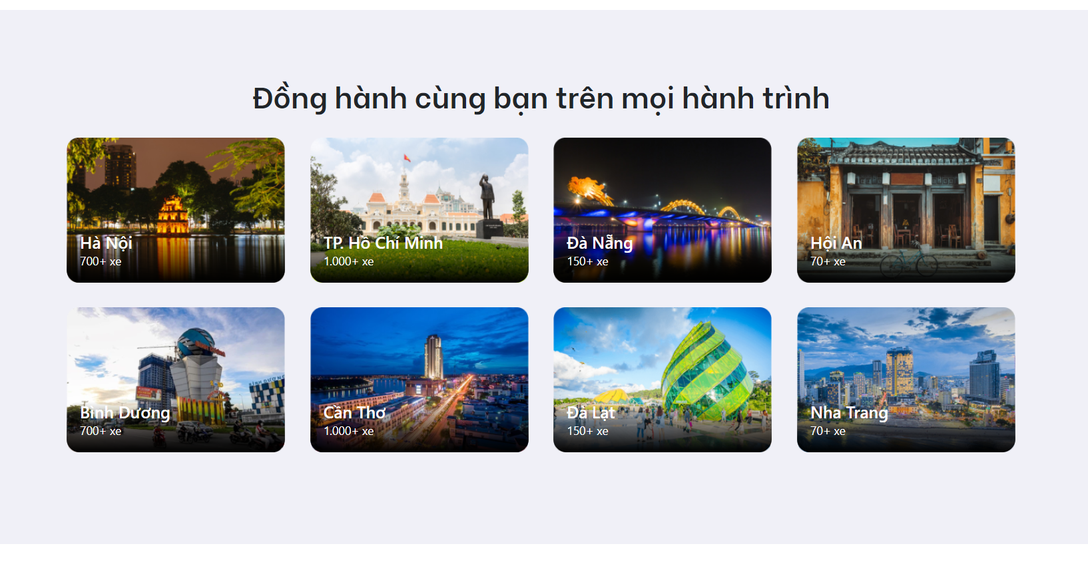

| Pros:   * Personalized. * Information is accurate and reliable. * Support Vietnamese | Cons:   * Users and car owners must download app of web to fill in their necessary informations. * Less informations. |
| --- | --- |

1.5. The Proposal System

* Online car rental service is a step forward from traditional car rental service. Although building an online car rental service has overcome many limitations of traditional services, the number of car rental websites with a user-friendly interface on the web is not many. The avis.com and xego.vn websites, as listed as examples, are among the largest service websites in this field, but there are still limitations related to personal information registration. In the immediate future, we want to create a website that has the function to fill in important information of individual car renters and owners. Besides, we want the website to have a convenient, user-friendly interface.
* The application will have functions to help users in their work most effectively. Functions such as Sign up, Login, Logout, Forgot password, Change password, Contact will help users synchronize and manage information on more than one device they use. We create the function to arrange rental time and search for the type of car the user wants to rent during the service experience. What we want is for the system to ensure the ability to verify the necessary information of both the car owner and the lessee, but the system can still omit unnecessary documents, ensuring security for every user.

1.6. Project Scope & Limitations

By our website, the job of managing car rental activities becomes easier and the method of operation becomes more professional. However, to be able to operate fully, our website still requires mandatory conditions, this is the limiting factor of this system.

* 1. The website requires a stable internet connection to launch smoothly.
* 2. The website does not have an accompanying mobile application.
* 3. Verifying documents takes time and requires precise operations as instructed.
* 4. We provide many mandatory requirements to be able to make car rentals and rentals when users register information, such as permanent address, ID card number...

2. 3. Responsibility Assignments

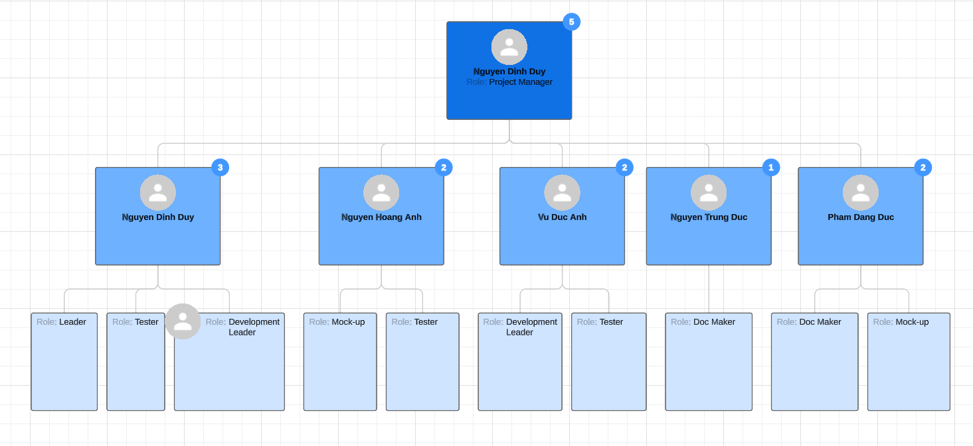

| No | Name | Roles | Responsibilities |
| --- | --- | --- | --- |
| 1 | Nguyen Dinh Duy | * Project Manager. * Technical Leader * Document Team Leader. * Development Team Leader. | * Managed and led the team project. * Analyzed and built materials for the project implementation process. * Developed project plan and implementation schedule. * Assigned responsibilities and tasks to members. * Removed any impediments that obstruct a team’s pursuit of its sprint goals. * Maintained an organization’s work flow and kept its lines of communication open. * Monitored the progress of project implementation * Identified, assessed and mitigated project risks for successful project completion. * Reviewed and supported requirement analysis. * Led requirement analysis team. * Understood clearly about project requirements and wrote SRS. * Maintained all documents by preparing standard templates, managing the process of creating, reviewing and updating documents in a team. * Researched algorithms and learned new techniques and architecture to use for projects. * Guided other members in the team to understand and to apply new techniques to the project. * Led a sub-team to develop the Android version. * Supported team members. |
| 2 | Vu Duc Anh | * Document Team Member. * Development Team Member | * Reviewed and supported requirement analysis. * Understood clearly about the project requirements and wrote SRS. * Identified certified solutions to meet the requirements. * Had a basic understanding of technology used for the project. * Guided other members to understand and to apply the technology to the project. * Summarized and made the project weekly report * Recorded the meeting-minutes. * Supported other team members. |
| 3 | Nguyen Hoang Anh | * Development Team Member. * Design Team Leader | * Had a basic understanding of technology used for the project. * Confirmed developing plan and assigned coding functions to other members. * Supported team in developing some functions. * Led a sub-team to develop the PC Version * Supported other team members. |
| 4 | Nguyen Trung Duc | * Development Team Member. * Test Team Member. * Document Team Member. | * Had a basic understanding of technology used for the project. * Read & understand SRS and deploy coding. * Optimized coding. * Executed testing. * Supported other team members. |
| 5 | Pham Dang Duc | * Test Team Leader. * Document Team Member. | * Supported requirement analysis. * Executed test cases, recorded test case results, documented and tracked defects, and performed test coverage analysis. * Supported team to develop some functions. |

3. 2. Use Case Specifications

**UC001 – Register:**

| **USE CASE – Authentication** | | | |
| --- | --- | --- | --- |
| **Use-case NO.** | UC001 | **Use-case version** | 1.0 |
| **Use-case Name** | Register | | |
| **Author** | Nguyen Dinh Duy | | |
| **Date** | 1/10/2023 | **Priority** | High |

**Actor:** Guest

**Summary:** Because the permission of guests is limited. So guest must register an account to be able to create sync data to the server.

**Goal:** Register an account in the system.

**Triggers:**

* Tap on the “Sign Up” button.
* Tap on the email field.
* Tap on the name field.
* Tap on phone number field
* Tap on address field
* Tap on the password field.
* Tap on the “Register” button.

**Preconditions:**

* User is in the login screen.
* Internet permission

**Post conditions:**

* An account is registered.

**Main success Scenario:**

| **Actor** | **System** |
| --- | --- |
| 1. Tap on “Sign Up” button on view Login for the first time to open application. |  |
|  | 1. Show “Sign Up” screen with: Name, Email, Password. |
| 1. Enter name, email, password. Then, tap on the “Sign Up” button. |  |
|  | 4. Check name, email, password is valid.   1. Show popup “Register successfully”. 2. Go to the Home screen. |

**Alternative Scenario:** N/A

**Exceptions:**

**User enter not validated name, email or password.**

| **Actor** | **System** |
| --- | --- |
|  | 1. Check name, email, password is valid. 2. Display error message to let customer alerts of the filling. |
| 1. Fill validated name, email, password. |  |
|  | 1. Check name, email, password is valid. 2. Show popup “Register successfully”. 3. Go to the Home screen. |

**Extensions:** N/A

**Relationships:** Change password function

**Business rules:** In order to log in to the system, username and password are required.

**UC002 – Login:**

| **USE CASE – Authentication** | | | |
| --- | --- | --- | --- |
| **Use-case NO.** | **UC002** | **Use-case version** | **1.0** |
| **Use-case Name** | **Login** | | |
| **Author** | **Nguyen Dinh Duy** | | |
| **Date** | **01/10/2023** | **Priority** | **Medium** |

**Actor:** All users

**Summary:** This use case allows users who have username and password to login to the system to use the system's functions. Function that users can use must be allowed by admin.

**Goal:** Allow user to login.

**Triggers:**

* Tap on “Login”.
* User enters username and passwords.
* Tap on “Login” button.

**Preconditions:**

* User have not logged in yet.
* Internet permission.

**Post conditions:**

* Logged account.

**Main success Scenario:**

| **Actor** | **System** |
| --- | --- |
| 1. Tap on the navigator menu item. |  |
|  | 1. **Show navigator menu** |
| 1. Tap on “login” |  |
|  | 1. **Show “Login” screen with: Email, Password.** |
| 1. Enter email, password. Then, tap on “Sign In” button |  |
|  | 1. **Show screen “Home Screen” with data of this account.** |

**Alternative Scenario:**

| **Actor** | **System** |
| --- | --- |
| 1. Tap on the “Sync” button on top left in Home screen. |  |
|  | 1. **Check if the user is logged.** 2. **Show “Login” screen with: Email, Password.** |
| 1. Enter email, password. Then, tap on “Sign In” button |  |
|  | 1. **Show screen “Home Screen” with data of this account.** |

**Exceptions:**

**Not fill email and password to field or fill wrong email and password.**

| **Actor** | **System** |
| --- | --- |
|  | 1. **Check validated email, password.** 2. **Show alert wrong email, password.** |
| 1. Enter validated email, password. Then, tap on “Sign In” button |  |
|  | 1. **Show screen “Home Screen” with data of this account.** |

**Relationships:** Change password function

**Business rules:** In order to log in to the system, user name and password are required.

**UC003 – Logout:**

| **USE CASE - Authentication** | | | |
| --- | --- | --- | --- |
| **Use-case NO.** | UC003 | **Use-case version** | 1.0 |
| **Use-case Name** | Logout | | |
| **Author** | Nguyen Dinh Duy | | |
| **Date** | 01/10/2023 | **Priority** | High |

**Actor:** All users

**Summary:** This user case allows users logged into the system can escape from the system.

**Goal:** Allow user to logout of the system.

**Triggers:**

* Tap navigator menu
* Tap on “Logout” button.

**Preconditions:** User has logged in successfully.

**Post conditions:** Go to view “Login”.

**Main success Scenario:**

| **Actor** | **System** |
| --- | --- |
| 1. Tap on “Logout” button |  |
|  | 1. Show “Logout” message to confirm action |
| 1. Tap on “Yes” button |  |
|  | 1. Go to view “Login” |

**Alternative Scenario:** N/A

**Exceptions:**

| **Actor** | **System** |
| --- | --- |
| 1. Tap on “No” button |  |
|  | 1. Cancel the logout action |

**Relationships:** Login function

**Business rules:** N/A

**UC004 – Change password:**

| **USE CASE – Authentication** | | | |
| --- | --- | --- | --- |
| **Use-case NO.** | UC004 | **Use-case version** | 1.0 |
| **Use-case Name** | Change password | | |
| **Author** | Nguyen Dinh Duy | | |
| **Date** | 01/10/2023 | **Priority** | Medium |

**Actor:** All users.

**Summary:** Change user password.

**Goal:** Change user account’s password.

**Triggers:**

* Tap on Change password.
* Input old password, new password, confirmed password.
* Tap on Change.

**Preconditions:**

* User is in the Settings screen.
* The Internet is available.
* Permission to use the internet .
* User is logged in.

**Post conditions:**

* User back to Setting screen.

**Main success Scenario:**

| **Actor** | **System** |
| --- | --- |
| 1. Tap on Change password. |  |
|  | 1. Show Change password Popup. |
| 1. Input old password, input new password, input confirmed password. |  |
| 1. Tap on Change. |  |
|  | 1. Show popup. |

**Alternative Scenario:** N/A

**Exceptions:**

**User input wrong old password, wrong confirmed password:**

| **Actor** | **System** |
| --- | --- |
| 1. Input old password, input new password, input confirmed password. |  |
| 1. Tap on Change. |  |
|  | 1. Show Error popup. |

**Relationships:** N/A

**Business rules:** N/A

## 3.2. Functional Requirements

### 3.2.1. System Functional Overview

*[Provide functionality overview of software system: screen flow, screen descriptions, system user roles, screen authorization, non-screen functions, ERD]*

## 3.3. Non-Functional Requirements

### 3.3.1. Reliability

We always attach great importance to website reliability, because reliability determines the survival factor of a website.

We commit that all information provided on the website is accurate and reliable

### 3.3.2. Availability

Systems created using the platform should be generally available to users.

### 3.2.3. Security

Security is necessary for almost websites. Protect user information is important

### 3.3.4. Maintainability

The platform should contain interfaces that are extensible to allow new communication protocols to be added with ease.

### 3.3.5. Portability

We can connect our website by every device from pc to mobile. However, the condition is that the device must be connected to the internet

## 

## 3.4. Other Requirements…